User Manual  
Please open it in Eclipse and install the prerequisites(Maven,Cucumber plugins).

**Execute:**  
  
To kick off the execution use Testrunner class

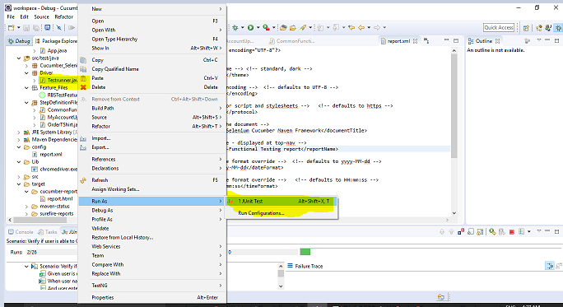  
 **Step Definition Files:**

Please find it in Cucumber_Selenium\src\test\java\StepDefinitionFiles

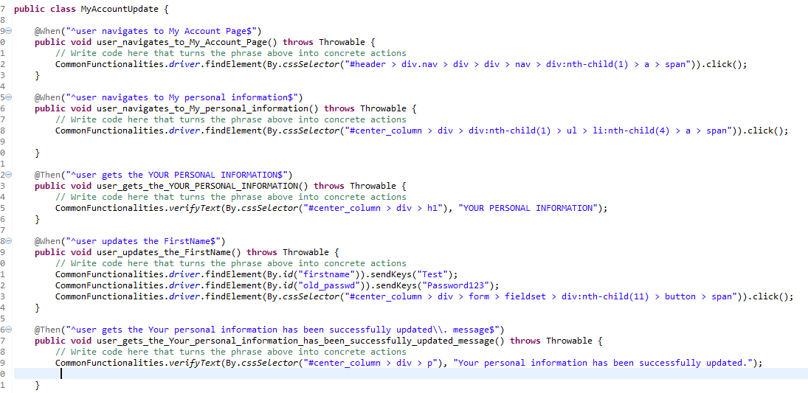

s  
**Feature File:**  
Please find it in Cucumber_Selenium\src\test\java\Feature_Files

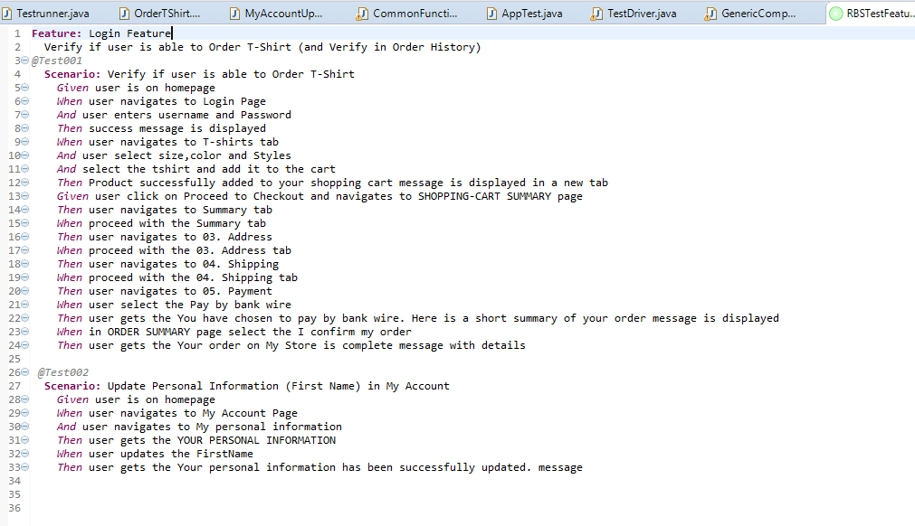  
  
**Reports**  
  
To see the report, after the execution please refresh and find it in Cucumber_Selenium\target\cucumber-reports\report.html  
  
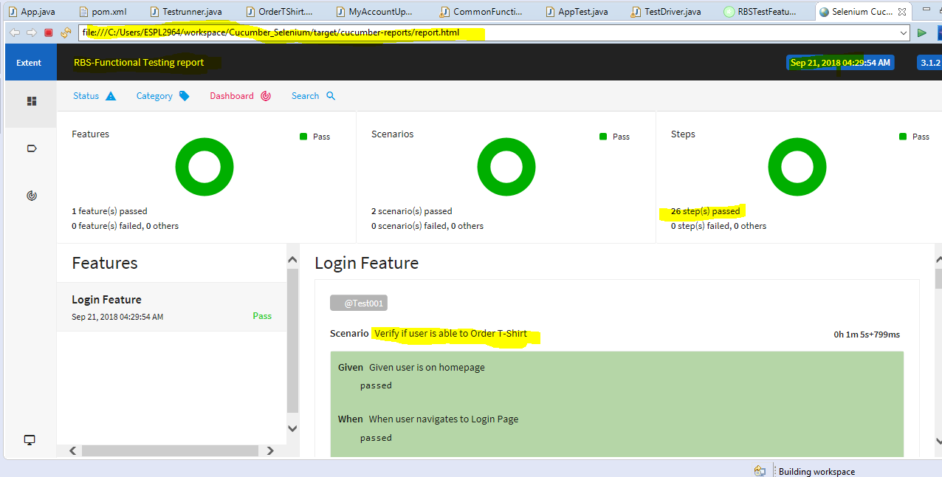

Please find the below screenshot for your reference.